Scorecard Management Requirements Specification

Scope

Overview
Scorecards provide the template to write reviews. Application can create, update or search scorecards with the API defined in the component. The scorecard persistence logic is pluggable.

Logic Requirements

Scorecard Type
A scorecard will be associated with a type. A scorecard type consists of
ID a numeric identifier
Name name of the scorecard type for display purpose

Scorecard Status
A scorecard will be associated with a status. A scorecard status consists of
ID a numeric identifier
Name name of the scorecard status for display purpose
There will be 3 built statuses for this release – Active, Inactive and Deleted. More status may be added in the future.

Scorecard

Scorecard
A scorecard consists of
ID a numeric identifier
Name name of the scorecard
Version version of the scorecard, will be a String
Type each scorecard will have a type
Status each scorecard will have a status
Category scorecard will be associated with a project category, this could be
represented by a numeric identifier
Minimum Score the minimum acceptable score for the scorecard
Maximum Score the maximum acceptable score for the scorecard
Currently In Use a Boolean flag indicating whether the scorecard is currently in use,
scorecards in use are read only.
Groups one or more ordered scorecard groups as specified in 1.2.3.2

Scorecard Group
A scorecard group consists of
ID a numeric identifier
Name name of the group
Weight weight of the group in the scorecard, weights of groups in a single
scorecard should add up to 100
Sections one or more ordered scorecard sections as specified in 1.2.3.3

Scorecard Section
A scorecard section consists of
ID a numeric identifier
Name name of the section
Weight weight of the section in the group, weights of sections in a single
group should add up to 100
Questions one or more ordered scorecard questions as specified in 1.2.3.4

Scorecard Question
A scorecard question consists of
ID a numeric identifier
Type each question will have a type as specified in 1.2.4
Description the textual description for the question
Guideline the optional scoring guideline for the question
Weight weight of the question in the section, weights of questions in a single
section should add up to 100
Document Upload a Boolean flag indicating whether the question allows an attachment
Upload Required a Boolean flag indicating whether the attachment is required

Scorecard Question Type
A scorecard question will be associated with a type. A question type consists of
ID a numeric identifier
Name name of the scorecard type for display purpose
The logic to evaluate the answer based on the question type is not in the scope of this component.

Scorecard Management Operations
Despite manipulation of the scorecard structure defined above, this component will support the following operations.

Create Scorecard
A new scorecard can be created. The identifiers will be provided with ID Generator. Scorecard should be validated according to the defined rules.

The operator needs to be provided for auditing purpose.

Update Scorecard
An existing scorecard can be updated. The identifiers of any new entities will be provided with ID Generator. Scorecard should be validated according to the defined rules.

When a scorecard is successfully updated, its minor version number should be incremented. The minor version number is the numeric value after the last dot in the scorecard version. If the minor version number does not exist then “.1” (dot one) should be appended to the version.

The operator needs to be provided for auditing purpose.

Get Scorecard
A scorecard can be retrieved by specified identifier.

Search Scorecards
An array of scorecards can be retrieved by specified search criteria. An option should be able to specify whether to retrieve the complete scorecard hierarchies or only the scorecard instances.

Scorecard Search Criteria
At minimum, the criteria should be capable of specifying any combination of scorecard type, scorecard status, project category, project, name and version.

If scorecard status is not specified, Active should be assumed.

All Scorecard Types
There should be a way to retrieve all scorecard types in the system.

All Question Types
There should be a way to retrieve all question types in the system.

All Scorecard Statuses
There should be a way to retrieve all scorecard statuses in the system.

Search Builder Usage
Search Builder should be used with the searching functionality. Only the identifiers of the entities should return from the Search Builder. Convenient methods should be provided to create the applicable filters.

Auditing Fields
Scorecard must also include auditing fields of creation/modification operator and timestamp. These fields will not be provided by component users.

Persistence
Persistence needs to be pluggable. For this release an Informix plug-in will be developed. The SQL scripts will be provided.

Persistence Implementation
The persistence implementation needs to be designed in this component, but will be separated into a second development project. Please put all persistence implementation related information into a separate sub-package and clearly mark the responsibilities of the two development projects.

Informix Plug-in
Notice for this plug-in the in use attribute of the scorecard is read only. It will be true if there are one or more rows in the project_scorecard table, false otherwise.

Required Algorithms
No specific algorithms are required.

Example of the Software Usage
A scorecard/review application can use the component as a model layer. Application user can create and modify scorecards on the web interface.

Future Component Direction
Separate component will be developed to calculate review scores. XML persistence plug-in can be developed to provide better drop in convenience.

Interface Requirements

Graphical User Interface Requirements
None.

External Interfaces
Design must adhere to the interface diagram definition. Designer can choose to add more methods to the classes/interfaces, but must keep the ones defined on the diagram as a minimum. Source files can be found in the distribution.
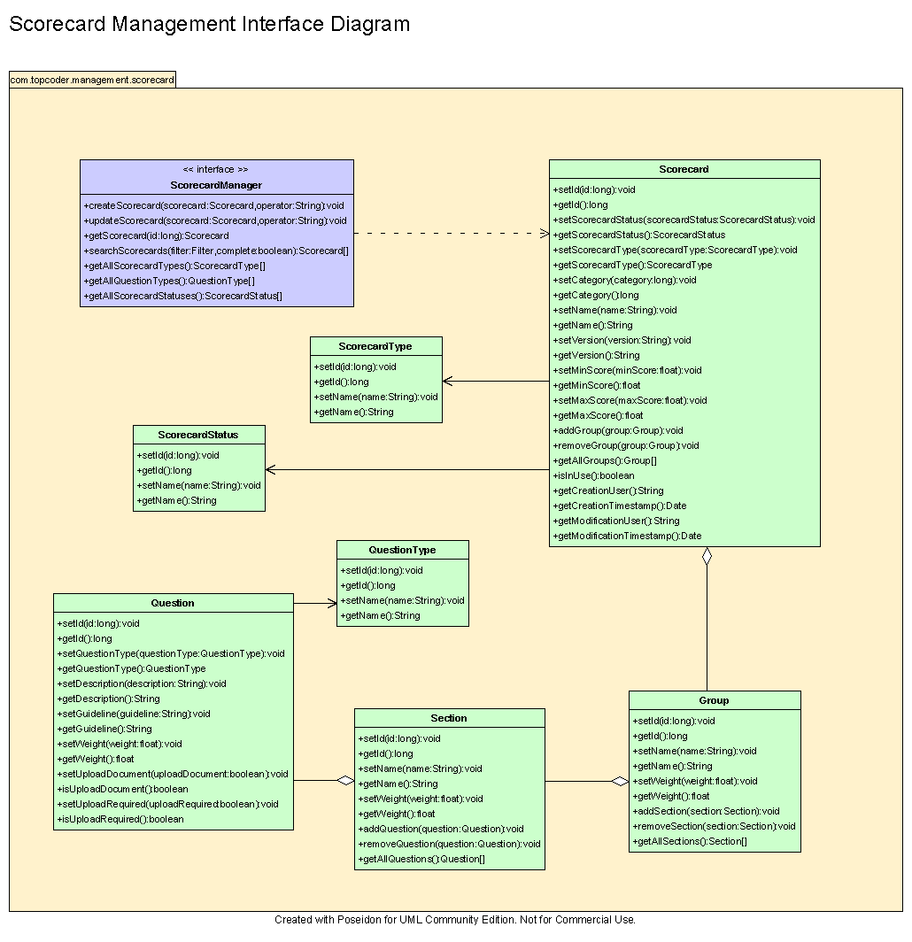

Environment Requirements
- Development language: Java1.4
- Compile target: Java1.4

Package Structure
com.topcoder.management.scorecard

Software Requirements

Administration Requirements

What elements of the application need to be configurable?
- Database connection

Technical Constraints

Are there particular frameworks or standards that are required?
JDBC

TopCoder Software Component Dependencies:
- Configuration Manager
- DB Connection Factory
- ID Generator
- Search Builder

**Please review the TopCoder Software component catalog for existing components that can be used in the design.

Third Party Component, Library, or Product Dependencies:
None.

QA Environment:
- Solaris 7
- RedHat Linux 7.1
- Windows 2000
- Windows 2003
- Informix 10.0

Design Constraints
The component design and development solutions must adhere to the guidelines as outlined in the TopCoder Software Component Guidelines.

Database Connections
Database connections must not be cached within the component. Connections should be created for each operation and closed afterwards.

Component Scalability
The component needs to be scalable. Running multiple instances in the same JVM or in multiple JVM’s concurrently should not cause any problem.

Required Documentation

Design Documentation
- Use-Case Diagram
- Class Diagram
- Sequence Diagram
- Component Specification

Help / User Documentation
- Design documents must clearly define intended component usage in the ‘Documentation’ tab of Poseidon.

